Group assignment answer sheet for Lab test 2
Student ID | Student Name
14657314
Note: each group only submit one answer sheet. Do not submit it multiple times! When you finish the assignment, attach this file to an email, send it to your lead tutor, and cc to your group members.
Question: Set up static networking 10.0.2.0/24 for your CentOS and a dynamically assigned IP address for your Windows Server given the following parameters, based on Lab test 1:
 | CentOS | Windows Server
IP addressing: | 10.0.2.1 | DHCP assigned
Interface: | ens192 | Ethernet1
DNS Suffix or  Search Domain: | it.uts.edu.au | it.uts.edu.au
DNS: | 8.8.8.8 | DHCP assigned
Gateway: | 10.0.2.1 | DHCP assigned

Configure a DHCP4 service in CentOS, set the IP pool range to 10.0.2.101 – 10.0.2.200, and test the Windows client using Ethernet1.
Provide a screenshot of each command.
CentOS
1. ifconfig ens192
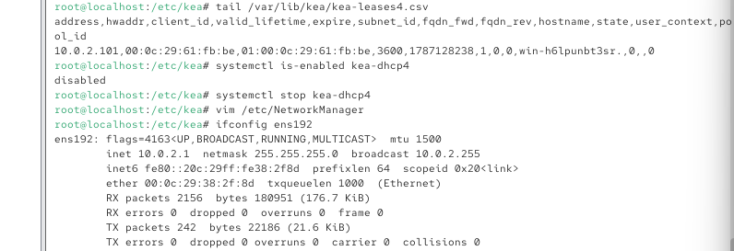
2. systemctl status kea-dhcp4
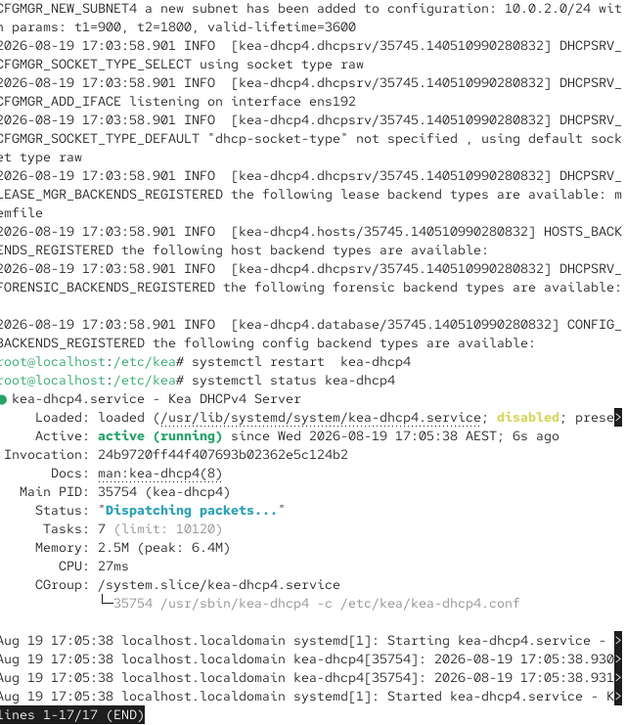
3. tail /var/lib/kea/kea-leases4.csv
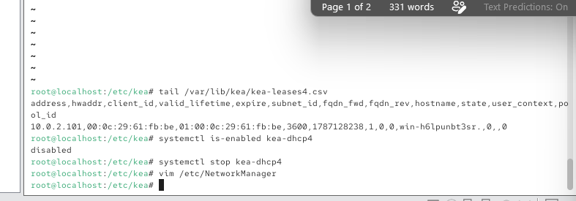
4. sed -n '/"subnet4"/,/]/p' /etc/kea/kea-dhcp4.conf
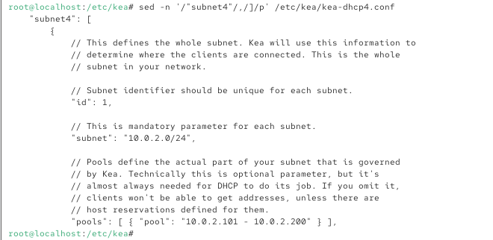
Windows Server
1. ipconfig /all
[ TO BE ADDED — screenshot of ipconfig /all from Windows Server ]
2. ping 10.0.2.1
[ TO BE ADDED — screenshot of ping 10.0.2.1 from Windows Server ]

For the first skill test, please check the items and choose one of them to sign, as part of the lab test submission (no marks for the followings).
- I have prepared a portable hard drive or USB 3.0 flash drive with at least 64GB, and
- I have formatted the hard drive to exFAT, and
- I have downloaded the two ova files (CentOS 10 and Windows Server 2025) and re-imported them to two directories, each of which contains the .vmx file, ready to boot, on the portable hard drive and
- I have prepared a Windows 11 x64 laptop and installed the VMWare to run the two VMs, or
- I will use the lab PC with Redhat for skill assessment.
Choose one of the following and sign
- I have completed the preparation described as above.

- I have not done the preparation but will complete it before the lab session in week 5.

- I have not done the preparation and will take my own responsibility for the skill test in week 5.

